

**A 12**

**Sreenidhi Institute of Science & Technology**

(An Autonomous Institution)

**Code No: 121EE41**

**B. TECH. I – Year II – Semester Examinations, July, 2014 (Regular)**

**BASIC ELECTRICAL ENGINEERING (BT)**

**Time: 3 Hours Max. Marks: 70**

**Note: No additional answer sheets will be provided.**

**Part-A**

**Max.Marks:20**

**answer all QUESTIONS.**

1. Define Ohm’s law.

2. Define Peak factor.

3. What are the Different losses in a DC Generator?

4. Define Transformer.

5. What is the principle of3-Phase Induction Motor?

6. MI and MC instruments where we are going to use.

7. State KCL and KVL.

8. Convert 8+J6 in to polor form.

9. What is the Torque Expression for a DC Motor?

10. Types of DC Motors.

**Part – B**

**Max. Marks: 50**

**ANSWER ANY FIVE QUESTIONS. EACH QUESTION CARRIES 10 MARKS.**

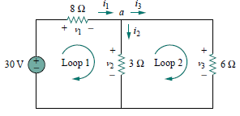1. Find the currents and voltages

in the circuit shown in Fig.

2. a) Find the average and effective values of the cosine wave .

b) A sinusoidal source (230 V, 50 Hz) feeds an inductive load which absorbs 8 A and 1000 W.

Calculate the PF, Q and S in the load.

3. Explain the DC Generator Principle and Construction? Also mention the types of DC Generator.

4. Explain the Principle and Construction of Transformer? specify the type of it and losses in it.

5. Explain the Principle and construction of 3-phase Induction motor. Derive the Torque

Expression.

6. Explain in detail Classification of Measuring Instruments?

**7.** A 4 kVA, 200/400 V, 50 Hz, single-phase transformer gave the following test results:

OC test (LV side): 200 V, 0.8 A, 75 W

SC test (HV side): 20 V, 10 A, 90 W

Calculate the parameters of the transformer referred to as LV side. Find the regulation and efficiency of the transformer for full load and half load both at 0.8 power factor lagging.

**8.** Find *R*eq at terminals *a*-*b* for the circuits in Fig. below:

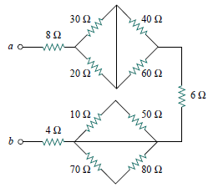

**-- 00 -- 00 --**